SYSTEM REQUIREMENTS
- Functional Requirements
- System shall allow waste pickers to register at a buy-back centre (name, ID number, phone number).
- System shall enable buy-back centre staff to record each recyclable material transaction (picker, material type, weight/quantity, price, total paid).
- System shall maintain a price list for recyclable materials (per kg or per unit).
- System shall calculate and display an income board for each waste picker (daily, monthly, total).
- System shall generate an environmental dashboard with monthly material collected and the overall environmental impact.
- System shall provide an AI-based material trend tracker showing which materials are increasing in volume and demand.
- System shall integrate a Google maps API to display buy-back centre locations.
- System shall support three roles: User (buy-back centre staff), Admin, Super Admin.
- Non-Functional Requirements
- AI trend predictions refresh daily (off-peak hours).
- System must handle up to 50 concurrent buy-back centre users.
- Page load time must be less than 5 seconds.
- All financial transactions and any system changes must be recorded/logged.
- Environmental dashboard refreshes monthly

OVERVIEW OF FUNCTIONS AND NON-FUNCTIONS
Functions:
- Register waste pickers
- Record transactions
- Update material prices
- View earnings by picker
- View monthly material leaders on the income dashboard
- View trending materials on AI trend tracker
- Google Maps API shows centres with statistics
- Three roles allow access to the app/system.
Non-Functions:
- User/Admin can register waste pickers
- Only Admin/super Admin can edit prices
- System handles 50+ buy-back centres concurrently
- The system refreshes daily
- There is strict access control for each user
- The app is responsive for all mobile users

SEQUENCE DIAGRAM(S)
- User registration and authentication
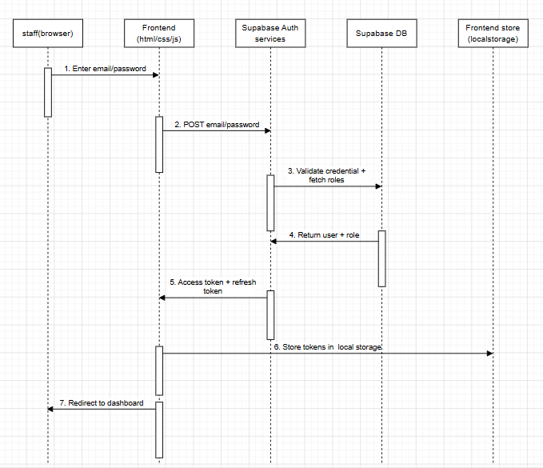
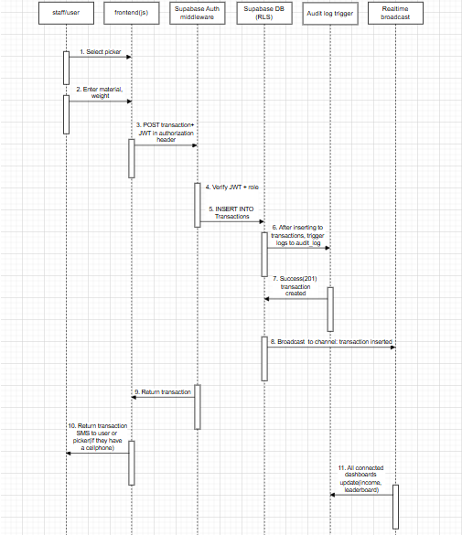
- Recording a transaction

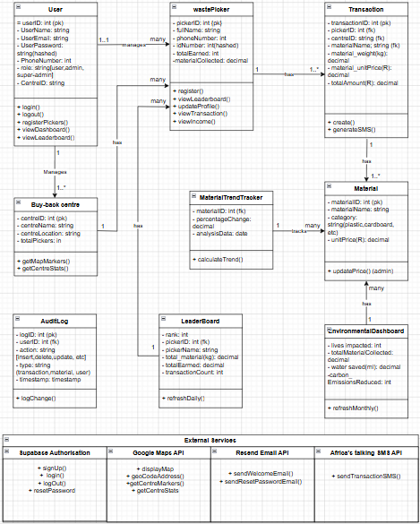
UML DIAGRAM

SYSTEM ARCHITECTURE DIAGRAM
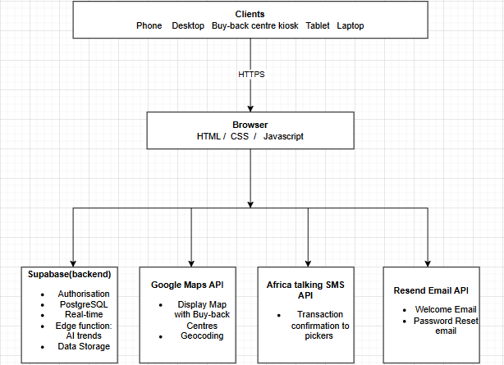

API REQUIREMENTS (Table format)
API Integrations Overview
EcoCycle integrates three external APIs to provide real-time location mapping, email communication, and SMS notifications. These APIs enhance the platform's functionality and enable it to interact with external services beyond the core application logic.
API 1: Google Maps Geocoding API
API requirements:
Property | Details
Provider | Google Cloud Platform
API Name | Google Maps Geocoding API
Base URL | https://maps.googleapis.com/maps/api/geocode/json
Authentication | API Key (stored in server .env as GOOGLE_MAPS_API_KEY)
HTTP Method | GET
Required Parameter | address — the place name to geocode
Required Parameter | key — your Google Maps API key
Optional Parameter | countrycodes=za — restrict results to South Africa
Response Format | JSON
Cost | Free tier — $300 Google Cloud credits
Rate Limit | 50 requests per second
Caching | 24-hour server-side cache to minimise API calls
Status | Active and fully integrated

Internal Backend Routes Using This API:
Method | Endpoint | Description
GET | /api/locations | Returns all 6 zones with real Google Maps coordinates + depot locations
GET | /api/locations/region/:id | Returns real coordinates for a single zone by ID
GET | /api/locations/depots | Returns depot locations only (hardcoded, no API call)

How it works:
- Backend calls Google Maps API on GET /api/locations request
- Results are cached for 24 hours to avoid redundant API calls
- If API fails, hardcoded fallback coordinates are used automatically
- Frontend SuperAdminMap.js reads from /api/locations and places markers on the map
- API key is stored securely in .env — never exposed to the browser
API 2: Resend Email API
API requirements:
Property | Details
Provider | Resend (resend.com)
API Endpoint | https://api.resend.com/emails
Authentication | API Key in Authorization header (Bearer token)
HTTP Method | POST
Content-Type | application/json
Required Fields | from, to, subject, html
Node.js Package | resend (npm install resend)
Cost | Free tier — 3,000 emails per month
Rate Limit | 2 requests per second on free tier
From Address | EcoCycle <onboarding@resend.dev> (testing mode)
Production Requirement | Verified domain (e.g. ecocycle.co.za)
Status | Integrated — domain verification needed for production

Internal Backend Routes Using This API
Method | Endpoint | Description
POST | /api/auth/register | Triggers welcome email after successful account creation
POST | /api/auth/forgot-password | Triggers password reset email with secure token link
POST | /api/auth/reset-password | Validates token and resets password (no email sent)

Email Types
Property | Details
Welcome Email | Sent on registration — subject: "Welcome to EcoCycle!"
Password Reset | Sent on forgot-password — subject: "Reset Your EcoCycle Password"
Reset Link Format | http://localhost:3000/reset-password?token={token}
Token Expiry | 1 hour — token is invalidated after use

How it works:
- User submits Forgot Password form → POST /api/auth/forgot-password called
- Backend generates a unique secure token and saves it with 1-hour expiry
- Resend API called to send HTML email with reset link to user's email
- User clicks link → taken to reset password page → enters new password
- Token is cleared after use — cannot be reused
- Welcome email sent automatically on every new registration
- API key stored in .env — never exposed to frontend
API 3: Africa’s talking SMS API
API requirements:
Property | Details
Provider | Africa's Talking (africastalking.com)
API Endpoint | https://api.africastalking.com/version1/messaging
Authentication | API Key + Username in request headers
HTTP Method | POST
Content-Type | application/x-www-form-urlencoded
Required Fields | username, to, message
Optional Fields | from (sender ID), bulkSMSMode
Node.js Package | africastalking (npm install africastalking)
Cost | Free sandbox for testing — pay per SMS in production
SA Networks | Vodacom, MTN, Cell C, Telkom — all supported
Phone Format | Must include country code e.g. +27821234567
Current Mode | Sandbox (testing environment)
Status | Integrated and working in sandbox mode

Internal Backend Routes Using This API
Method | Endpoint | Description
POST | /api/transactions | Records transaction AND automatically sends SMS to picker
POST | /api/admin/pickers | Registers picker AND sends welcome SMS to picker's phone

How it works:
- Employee records a transaction via the Record Transaction page
- Frontend calls POST /api/transactions with picker and material details
- Backend saves the transaction and immediately triggers SMS notification
- SMS is sent asynchronously — does not slow down transaction recording
- If SMS fails, the transaction is still saved (SMS failure is logged only)
- Phone numbers stored in picker profile — no manual input needed per transaction

Internal API Routes (Backend)

Authentication Routes
Method | Endpoint | Description
POST | /api/auth/register | Create new account — sends welcome email via Resend
POST | /api/auth/login | Login — returns JWT token + user role
GET | /api/auth/me | Get current logged in user info
GET | /api/auth/pending | Get all accounts pending approval
PUT | /api/auth/approve/:id | Approve a pending account
POST | /api/auth/forgot-password | Send reset email via Resend API
POST | /api/auth/reset-password | Reset password using emailed token
POST | /api/auth/change-password | Change password (logged in users)
PUT | /api/auth/profile | Update profile name or email

Admin Routes
Method | Endpoint | Description
GET | /api/admin/pickers | Get all registered pickers
POST | /api/admin/pickers | Register picker — sends welcome SMS via Africa's Talking
DELETE | /api/admin/pickers/:id | Remove a picker by ID
GET | /api/admin/stats | Get dashboard statistics (totals, earnings, kg)

Materials Routes
Method | Endpoint | Description
GET | /api/materials | Get all material prices
GET | /api/materials/:id | Get single material price by ID
PUT | /api/materials/:id | Update material price (admin/superadmin only)

Transactions Routes
Method | Endpoint | Description
GET | /api/transactions | Get all transactions sorted by newest first
POST | /api/transactions | Record transaction — auto-calculates total + sends SMS
GET | /api/transactions/summary | Get transaction stats for dashboards
GET | /api/transactions/picker/:id | Get all transactions for one picker

Locations Routes (Google Maps API)
Method | Endpoint | Description
GET | /api/locations | Get all zones with Google Maps coordinates + depots
GET | /api/locations/region/:id | Get single zone with real GPS coordinates
GET | /api/locations/depots | Get all depot locations

Rewards Routes
Method | Endpoint | Description
GET | /api/rewards | Get leaderboard — all pickers ranked by XP
GET | /api/rewards/:picker_id | Get XP, level and badges for one picker
POST | /api/rewards/add | Add XP to a picker — auto-awards badges on thresholds

Health Check
Method | Endpoint | Description
GET | /api/health | Check if server is running — returns status and timestamp

Authentication Details
Property | Details
Type | Bearer Token (JWT)
Header | Authorization: Bearer {token}
Token Expiry | 7 days
Roles | user, admin, superadmin
Token Storage | localStorage (key: ecocycle_token)
User Storage | localStorage (key: ecocycle_user)

HTTP Status Codes
Property | Details
200 | OK — Request successful
201 | Created — Resource created successfully
400 | Bad Request — Missing or invalid data
401 | Unauthorized — Not logged in or invalid token
403 | Forbidden — Logged in but wrong role
404 | Not Found — Resource does not exist
500 | Server Error — Something went wrong on the server

DESIGN JUSTIFICATION
- Front-end
We used Html/CSS/Javascript for our front-end because they are lightweight languages and run on any device including mobile devices used by many, if not all buy-back centre employees/users. They are also easy to maintain for future maintenance purposes.
- Supabase for backend/database
Provides fast full database functionality, authentication, and real-time updates and data syncing. Helps enforce role-based access at database level, preventing unauthorized data access.
- Google maps API
Google maps provides a familiar interface and reliable geocoding. It helps pickers locate nearest buy-back centres. It also has clickable markers with centre statistics to improve accessibility for informal waste pickers.
- Income dashboard
The dashboard is accessible by all roles. The user(staff member(s)) can inform the waste pickers of their earnings, which helps build trust with the informal pickers. The admin or super-admin can monitor the performance of the buy-back centres. They can also calculate daily or monthly total from the transaction history.
- Leaderboard
The leaderboard measures waste picker performance and gamifies recycling, which may motivate the waste pickers. It also encourages healthy competition and increased waste material collection, resulting in the overall reduce of pollution and littering.
- Role design
User role(buy-back centre staff): The staff member can register new waste pickers, record transactions, and view all dashboards. They cannot modify material prices or add new centres and this helps prevent financial fraud.
Admin role: Has access to all user permissions plus can update material prices. They can also view all centres under their management. They cannot create new centres or delete users.
Super-admin role: Has full system access, they can add or edit buy-back centres, manage user accounts(create, disable, change roles, and delete), view full audit logs(recorded transactions). This helps ensure the platform’s proper and secure governance.

SLOTTING DIAGRAM
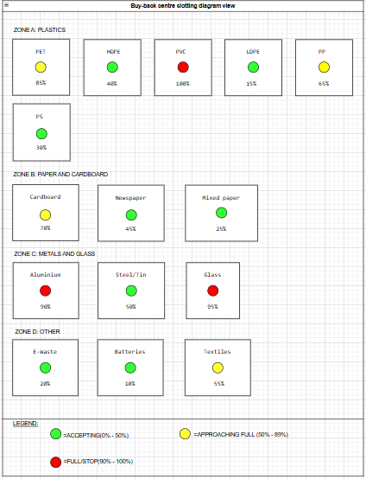

USER INTERFACE
Role-Based Views
Waste Picker (View Only – via kiosk or staff)
- Income board (chart + table)
- Transaction history
User (Buy-Back Centre Staff)
- Dashboard: Quick transaction form
- Register new picker
- View price list (read-only, unless Admin)
- Income board for any picker
- Environmental dashboard
- Map of centres
Admin (Manages 1 or more centres)
- All User features +
- Edit material prices
- View all transactions across centres they manage
Super Admin
- All Admin features +
- Add/edit buy-back centres
- Manage user accounts (create/disable/delete)
- View full audit log(recorded transactions and changes to the system)

RESPONSIVENESS
Mobile-first responsive design
Most buy-back centre staff use mobile phones. We used the CSS grid and flexbox to ensure that forms and tables are usable on small screens. The body font also changes according to the screen size. If the width of the device’s screen is 568px or less, the font size reduces to 16px, and if the width of the device’s screen is 280px or less, the font size reduces to 14px.

